Video Game Creations
Each person must create a video game using gamestarmechanic.

You will need to create an account for this site. Use your school email. Once you are there, you need to complete each of the Quests. This is how you earn items for your games. There are extra challenges at the bottom that you can do to earn extra sprites and other items for your games. Do these outside of class.
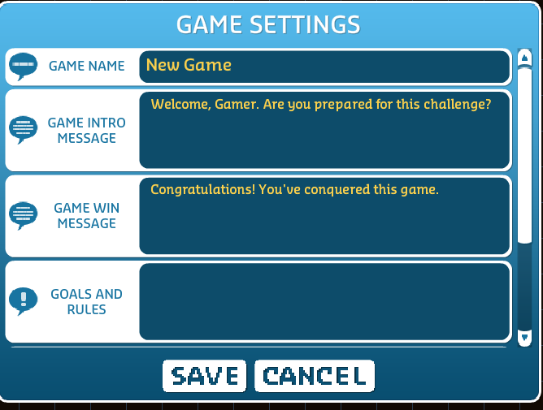
Once you finish the Quest, you are ready to make your own game.

Game Directions:
Give the game an interesting name. Once you name it, go to Settings (below Game Name) to put in information about your game. Refer back to other games to see what others have written.
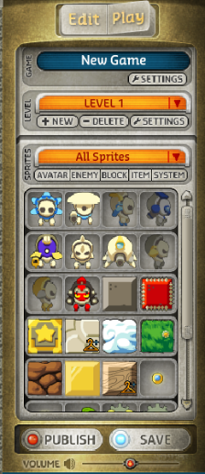
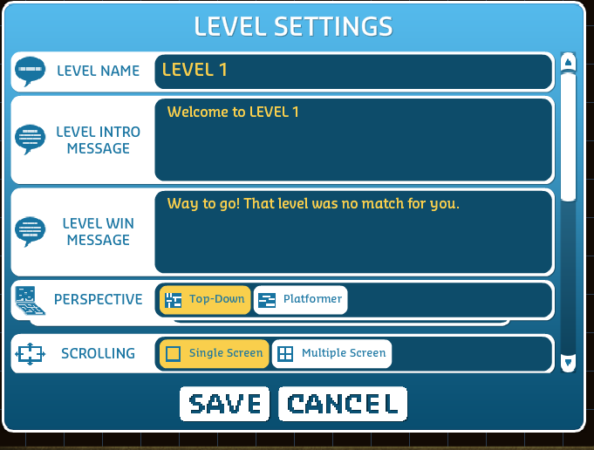
LEVELS: Your game needs to have at least five levels of increasing difficulty. Your levels should show creativity and variety. You need to have at least two Platform levels and two Top Down. The 5th level is your choice. To get a new level, just click on the NEW button below the Level indicator. For each level, fill out the level setting information so when a person plays it, they know the point of the level. Remember to Save and eventually Publish.
Once you have completed the game, create a Google Doc. Call it Video Game Creation + your initials. The document should include the following information:
- Your name
- Your username—needed to find your game
- Game Name
- Names of the Characters: (enemies, sprites, dinosaurs, etc.)
- Brief description of each of the 5 levels:
Example:

Level 1 goal:
- Do not run into the red blocks
- Try to get to the yellow block to win
- Use your gun to kill the enemies

Level 2 goals:
- Use your jump button to jump
- Land on the clouds or else you will die
- Get to the yellow block to win
- Kill the enemies
- Use your gun to kill the enemies

Share this document with me. This is what I will use to grade your game.
When you finish, I’d like you to play other students’ games. I will provide a list of usernames so you can search Game Alley for the games.
After you finish others’ games, click on the link to fill out an evaluation form: Video Game Evaluation Form

