Using Excel to create a graph (chart)
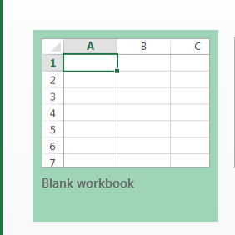
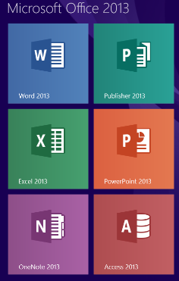
How to create a 2-D chart
To open an Excel document.
Go to start menu, open Microsoft Excel.
You will want a “Blank Workbook.”
The Workbook will look like the document below.
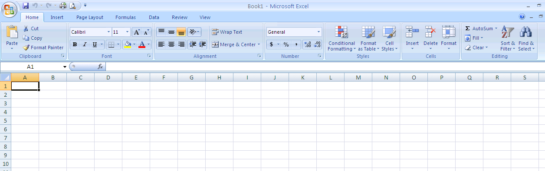

Step 2 - Enter the data to be graphed.

Step 3 - Highlight data to be graphed. Do not include the row with heading titles, only the names of fruit and the numbers. To highlight text as I did, put the cursor in cell A2, left click, hold the mouse button down and drag to cell B8. Highlighted data should look like the image to the right.
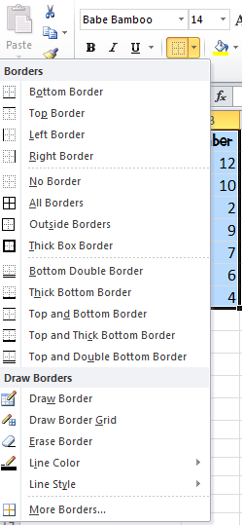
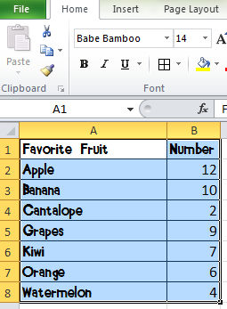
You might also want to put borderlines around your data table. To do this, highlight all of the text and press the down arrow next to the border button located on the Home tab above the word Font.
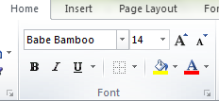

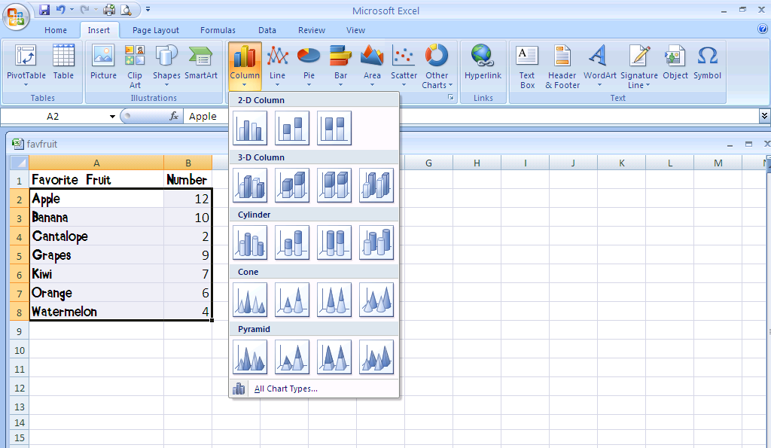
To create a graph (Excel calls this a chart),
2
3

1. Select data table.
2. Left-Click [Insert] tab.
3. Left-Click [2-D Column] button.
1

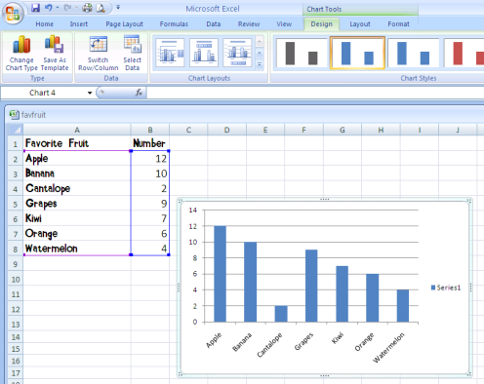
4. Select the chart that you want to use, and the computer automatically generates the chart.
4

5. Once your chart is created, additional features called “Chart Tools” become available. The chart tools, Design, Layout, and Format, are useful to add specific labels, titles, etc. to your chart.
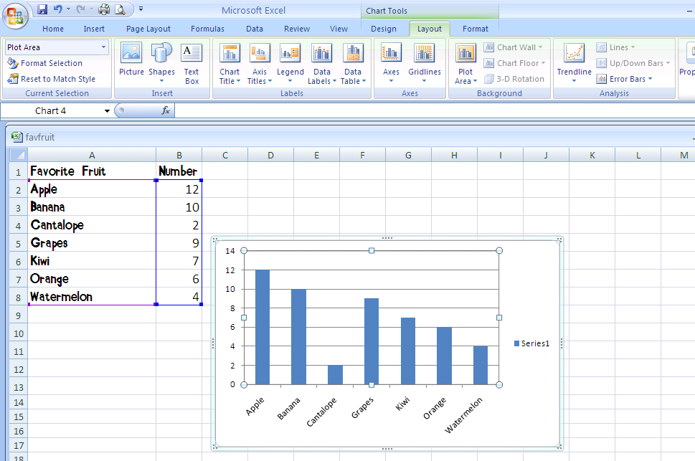
5

Make sure to include a title for your graph. This option is called “Chart Title.” Select it and a drop down menu appears. Once you make your selection, “Chart Title” appears on the chart. You simply type the title and press enter. “Chart Title” will be replaced and your title will appear.

Use the same procedure for typing your Axis titles. Don’t forget to do both the horizontal and vertical axis. Your chart (graph) should look like this.

All bars selected
At this point you may choose to make additional changes. You can change each of the bars to reflect the data in the graph. For example, in my Favorite Fruits graph, I decided to change each of the bars to reflect the type of fruit.
If you single click, all bars are selected. You can tell they are selected because there are dots on each corner of each bar. You can use this option if you want to change all bars at the same time to the same color, texture, or picture. However, if you want to change each bar individually, double-click (left) on the first bar you’d like to change. The only bar with dots on each corner will be the one that you double-clicked.
To make changes to each bar, right click on the bar you wish to change and a drop down menu appears. Click on Format Data Point.

Once you have clicked on “Format Data Point,” a dialogue box opens.
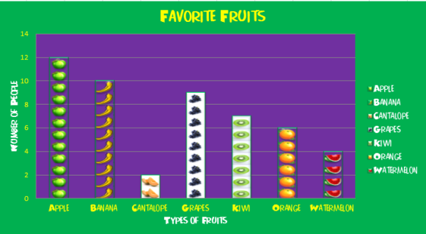
You want to select “Fill” and make change to each of the bars of your graph. You can change colors, textures, or even add clipart/pictures to the bars of your graph. Make sure to choose colors or pictures that are representative of the material the graph is showing.
Finished Graph

