Using Excel to create a graph (chart)
How to create a 2-D chart
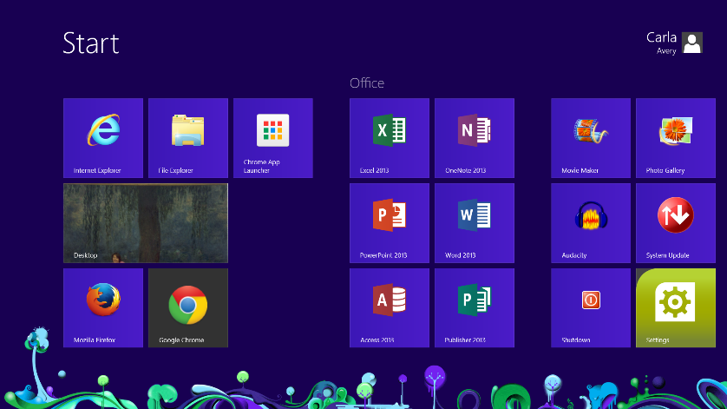
To open an Excel document.
Go to the Start menu. Click on Excel
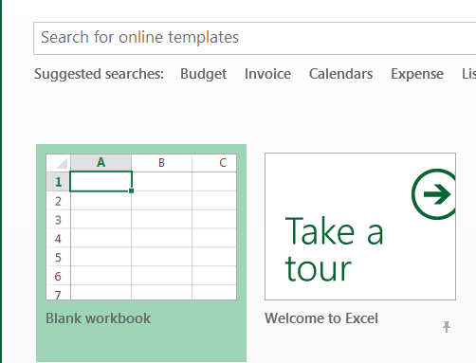
Select Blank Workbook.

The Workbook will look like the document below.
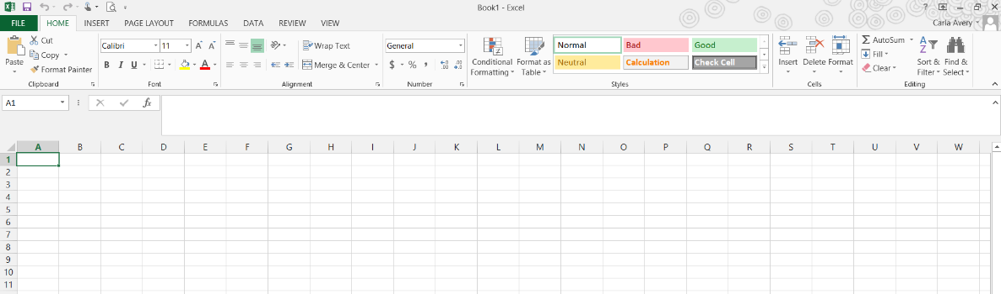

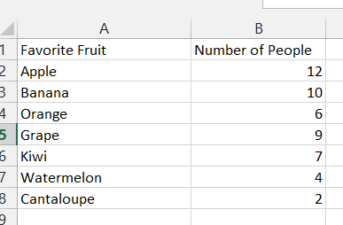
Step 2 - Enter the data to be graphed.
Note: To change column width easily, put your cursor between the letters (in this case A & B). You will notice a double arrow. When this appears, you may change the width of the column. This works for rows too.
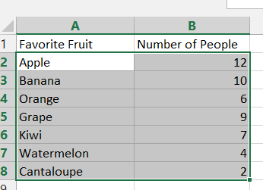
Step 3 - Highlight data to be graphed. Do not include the row with heading titles, only the names of fruit and the numbers. To highlight text as I did, put the cursor in cell A2, left click, hold the mouse button down and drag to cell B8. Highlighted data should look like the image to the right.
Select a 2D chart
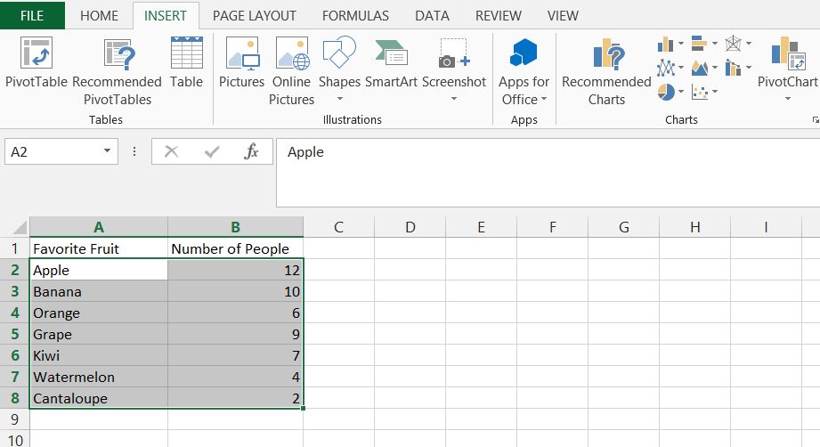
Step 4: Creating a graph (Excel calls this a chart),
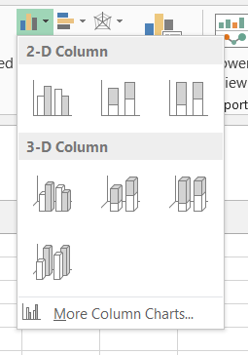
Once the data table is highlighted, select the Insert Tab.

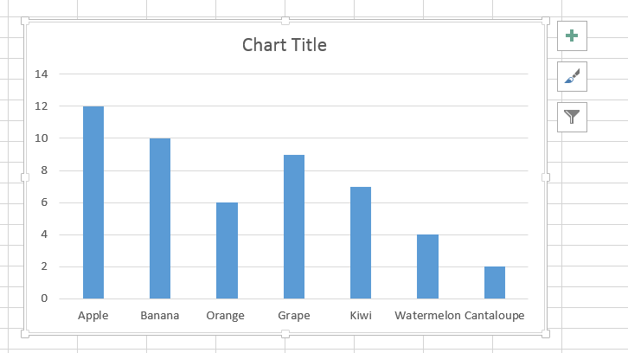
4. Select the chart that you want to use, and the computer automatically generates the chart.

Step 5. Formatting Your Graph
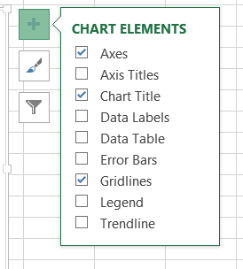
Once your chart is created, additional features called “Chart Tools” become available. The chart tools, Design and Format, are useful to add specific labels, titles, etc. to your chart. You will find these same features on the right side of the chart. The + sign allows you to add Labels.
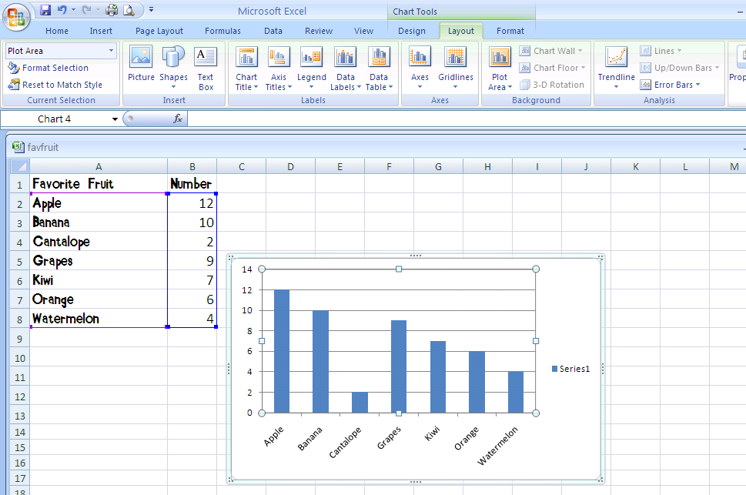
5

- Graph Title: Make sure to include a title for your graph. This option is called “Chart Title.” Select it and a drop down menu appears. Once you make your selection, “Chart Title” appears on the chart. You simply type the title and press enter. “Chart Title” will be replaced and your title will appear.

- Axes Labels: Use the same procedure for typing your axes (plural for axis) titles. Don’t forget to do both the horizontal and vertical axes. Your chart (graph) should look something like this.

3. Additional Options: At this point you may choose to make additional changes. You can change each of the bars to reflect the data in the graph. For example, in my Favorite Fruits graph, I decided to change each of the bars to reflect the type of fruit.
All bars selected
If you single click, all bars are selected. You can tell they are selected because there are dots on each corner of each bar. You can use this option if you want to change all bars at the same time to the same color, texture, or picture. However, if you want to change each bar individually, double-click (left) on the first bar you’d like to change. The only bar with dots on each corner will be the one that you double-clicked.
To make changes to each bar, right click on the bar you wish to change and a drop down menu appears. Click on Format Data Point.

Once you have clicked on “Format Data Point,” a dialogue box opens.
Notice that you have a variety of options to Fill your bars. If you choose picture, the picture must be saved on your computer to access it. Click on File to find your picture. It is best to save your pictures to your H: drive. (You can always create a new folder to keep your pictures together) However, Clipart is also an option.
The last thing you want to change is how the picture fills in the bar. Do you want it stretched, stacked, or stacked with a specific scale? In the example below, I stacked my fruit with a one to one ratio. In the apple bar, I had 12 people who selected apple as their favorite fruit. In the bar there are 12 apples in the bar.
Follow the same procedure for each bar of your graph.

Another option is to simply change all of the bars to different colors. You can do this in one easy step. In the Fill section, check the box “Vary colors by point” and the computer will automatically fill in the bar with different colors.

