The Times of My Life

A Personal & Historical Timeline

Create a timeline in which you find historical and personal events that have taken place in America.  Starting off with your birth, map out **ten meaningful events of your life**.  Then on the opposite side of the timeline, list out **ten important historical events** that have occurred from your birth – current day (that relate to US History!).  Then, next to each item on the timeline add a visual that represents the event.   If you use internet pictures, keep track of the URLs.

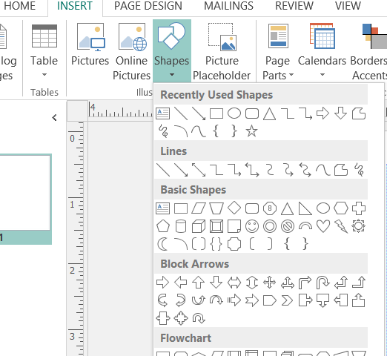Create the timeline in Microsoft Publisher.

Open Publisher—blank---landscape (11 x 24)

1. Draw a line—Insert—Shape—line
2. Hold Shift down while drawing the line to keep it straight. Place it in the middle of the page. Use the ruler to determine placement.
3. For each event use a rectangle or other shape* for each event. If you right click the shape you have the option to “add text.” You may have to resize the shape or text to fit properly.
4. Draw an arrow from the shape to the event.
5. *You might try a “Callout.” You can find them at the bottom of the Shape drop down menu. I’d recommend the first or second choice. The advantage is that they are text ready and have a built in control handle. To adjust the handle, select the callout, use the yellow square attached to the end of the handle, and move it to the correct location. Resize text and shape as necessary.



1. Do this for all twenty events—10 personal & 10 historical.
2. Find pictures, images, or icons to represent each event. If you get your picture from the internet, you must cite the source. Keep track of the URLs or web address for each image. (Not necessary for clipart.)



Third Event

Third Event

Second Event

Second Event

Birth 9/9/1959

'Neil Gordon Collie Smith, WI cricket all-rounder, dies in car crash. 9/9/1959