How to create a MLA formatted document
From the Start menu, choose New Microsoft Word Document. When the dialogue box opens, select Blank Document.
The alternate method is to go to Programs, Microsoft Office, Microsoft Word.
Once the Word document opens, complete the following steps to format your paper MLA style:
A MLA style paper has a 1-inch margin, is double-spaced, with no extra space before or after paragraphs, and uses Times New Roman, size 12, font style.
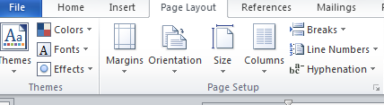
Setting up your Blank Document
1
Go to the Page Layout¹ tab. Select Margins², click on Normal.
2
3
Click on Orientation³ and make sure you have selected Portrait.
Double-space your Document
On the Home tab, go to the Paragraph group and click on the line spacing option
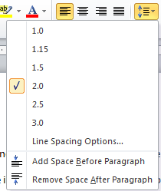
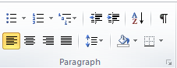
Line spacing
You need to select the down arrow, click on 2.0 for double spacing. Remember to remove space before and after paragraphs.
Font Style and Size
Change the font to Times New Roman, size 12
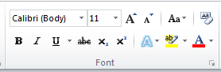
To change the font style, select the down arrow next to the type of Font on the Home tab. Scroll down until you get to Times New Roman or start typing in Times and TNR will appear. Click on the down arrow next to the size (number) and select 12.

Inserting a Page Number
Go to the insert tab. Select Page number. You will find this under the Header & Footer section.
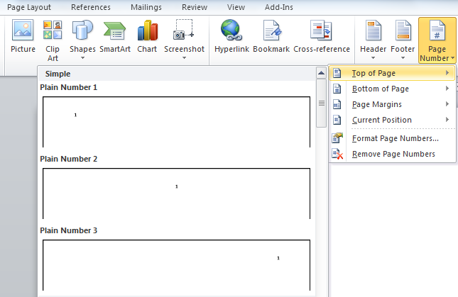
Once you click on page number, select “Top of Page,” Plain Number 3.
The page number is on the right side. Simply type your last name and hit the space bar to put a space between your last name and the page number. Highlight the text and change the font to Times New Roman, size 12 because it will default to Calibri, size 11. To close the header, double click on the page OR go back to the Insert tab and select Close HEADER AND FOOTER.
Now that most of your paper is set up, it is time to type the heading for the first page of your document.
The heading for your paper:
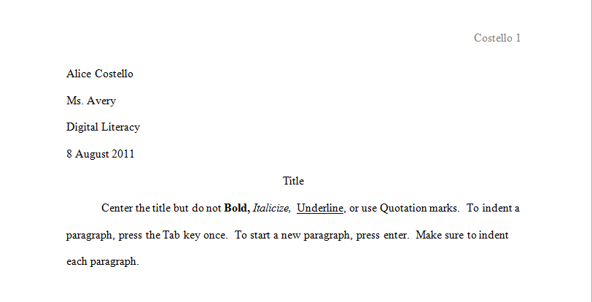
Start at the top of the page. Type the following:
Your first and last name
Your teacher’s name
Name of the class
Day Month Year

