Publisher Activities:
- Greeting Card-follow the instructions below. Please email me your final copy.

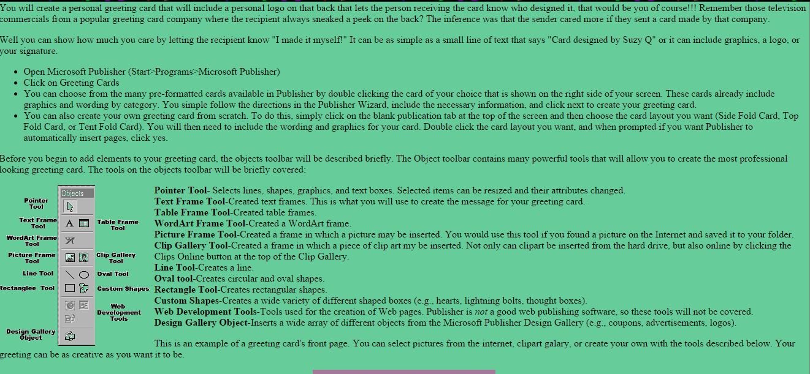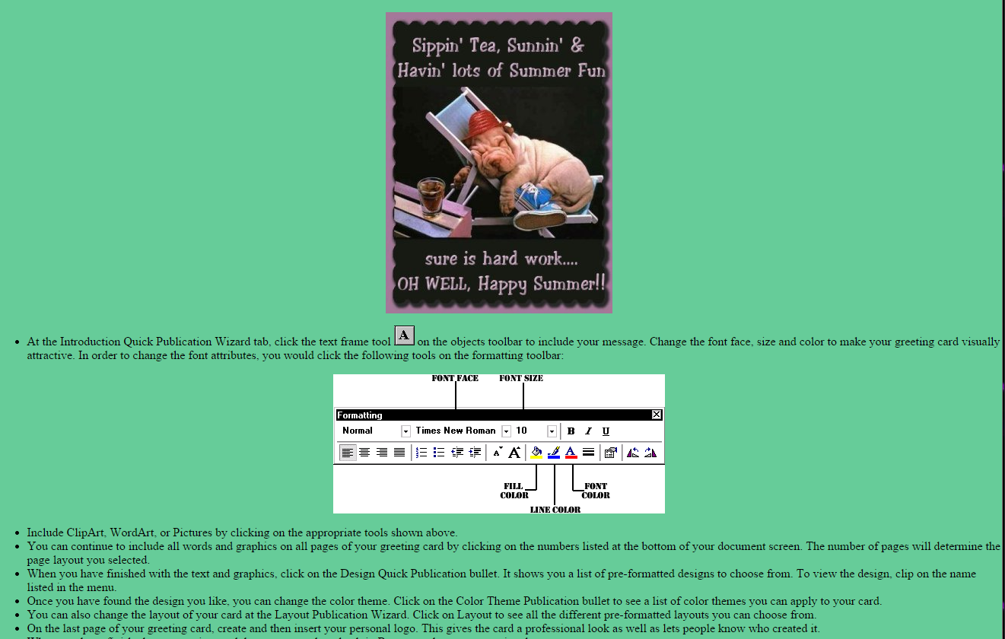

- Travel Brochure- pick a place that you would love to visit. Research online different activities and places to go there. Think about what will sell this place to others. You will be creating a brochure letting others know about this place. I have shared with you the directions. It is labeled ‘Travel Brochure’ to help you find it!

