Microsoft Office Activities
Please check off each assignment completed and send it to me for a grade.

Microsoft Word:
- You will be creating a seating chart of my room. You need to draw the tables, label the front of the room, label my desk in the back of the room, and label my computer cart. An example of this is:
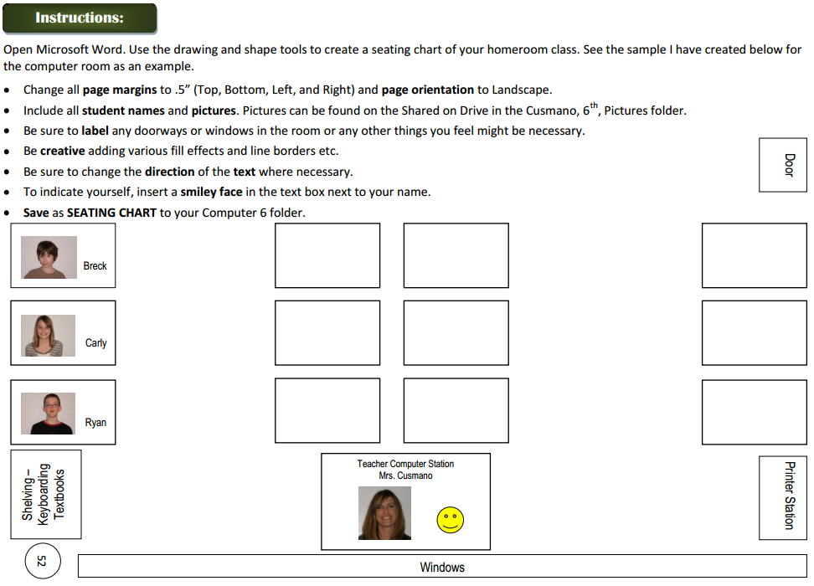
Follow all of the directions except you do not have to place pictures of students in there and I want you to save it to your Dig Lit 8 folder.

- Create a How To page on how to access and navigate around Google Cultural Institute. You will want to use the snipping tool on your computer and arrows to help you explain the directions. You will need at least 10 steps. Be sure to include how to get to each of the 3 categories (Art Project, Historical Moments, and World Wonders). Here is an example of a How To worksheet:
