Excel Basics

- Open Microsoft Excel

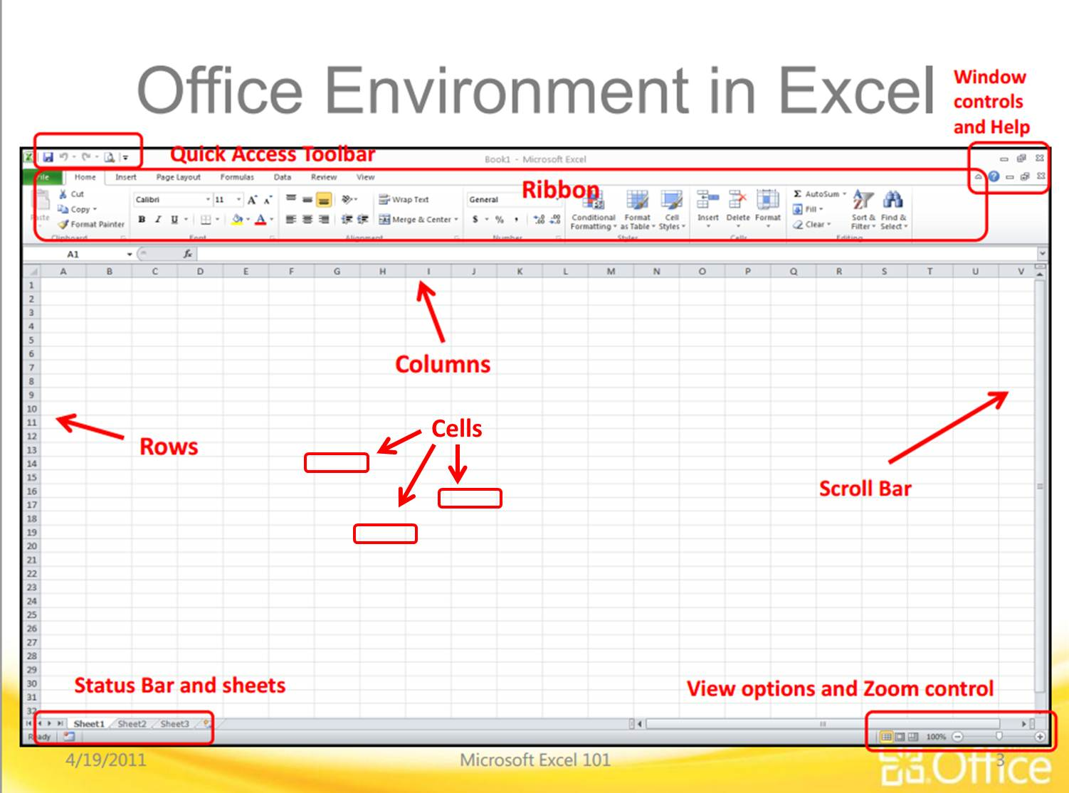
- Take a look at this picture to start learning the names of things in Excel:

Excel is used for making spreadsheets. A spreadsheet is used to organize information and numbers. You can make graphs and charts in excel. You can sort information. You can do math (even complicated math). You can make tables. You can do many things, but these are the basics that we will cover.

Now, answer the questions on the next pages using the picture and Excel on your computer.
- On your Ribbon, what are 3 things you see under the Home tab?

- On your Ribbon, what are 3 things you see under the Insert tab?

- On your Ribbon, what are 3 things you see under the Page Layout tab?

- On your Ribbon, what are 3 things you see under the Formulas tab?

- On your Ribbon, what are 3 things you see under the Data tab?

- On your Ribbon, what are 3 things you see under the Review tab?

- Under what tab can you find Column Charts?

- Under what 2 tabs can you add up numbers (Autosum)?

- Do Columns go up and down or side to side? (look at the picture on the first page)

- Do Rows go up and down or side to side? (look at the picture on the first page)

- What is a Cell?

- In Excel type something in one of the cells. As you are typing, where do the letters show up? (There are 2 places…)

- After you finishing typing, press “Enter” – Where do the letters show up now?

- How do you change the font and size of what you typed?

- How do you change the width of a column or row?

Finally, show me everything you did and I’ll record your grade!

