Digital Footprint Adventure
Search yourself through the following sites. Take notes on what you find in each search.

- Google search- go to www.google.com and search for yourself.
  - Put your name in “quotations”
  - Use the time range (shown in the steps below) option once you have hit search
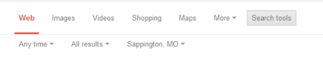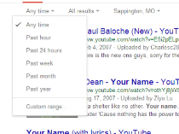
- Use these sites to search:
  - www.zabasearch.com
  - https://pipl.com
  - www.peoplefinders.com
  - www.switchboard.com

