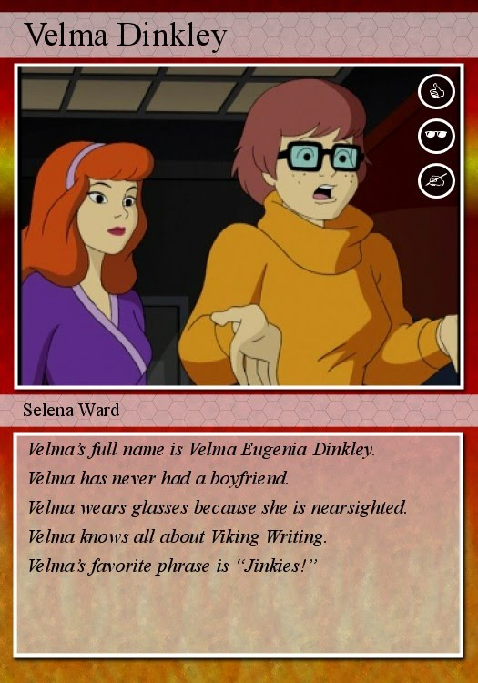
Cartoon All Star Card
Step One: Decide which is the best cartoon character of all time.
Step Two: Use the Internet to find and an image of that character. It is easy to go to images.google.com -->
find an image --> right click --> save image as....
Step Three: Use the Internet to find five interesting or unknown facts about your character.
Type them in your own words on Microsoft Word 2010.
Step Four: Click here to create your cartoon character's all star card.
There is no saving on this site so you need to complete it.

THIS IS JUST AN IMAGE. The steps below help you make your card.
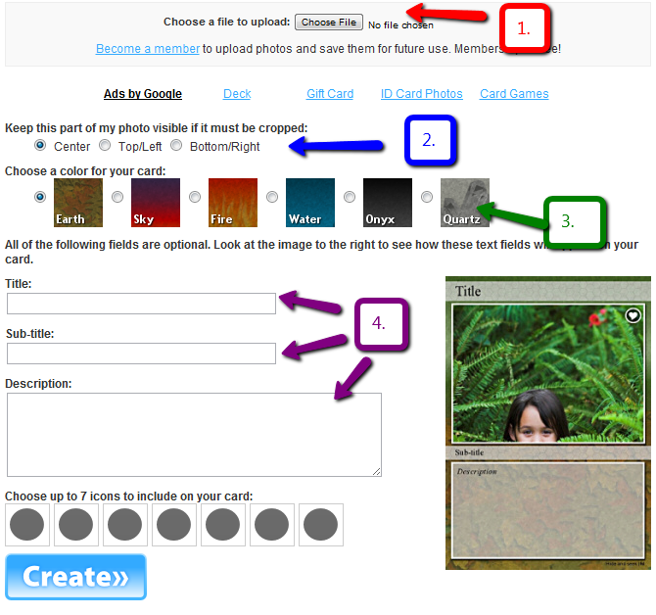

1. Choose File and pick your cartoon image you saved.
2. Leave the choice on center.
3. Choose the color choice you want for the card.
4. Title: Should be your character's name with proper capitalization. Subtitle: Your name with proper capitalization. Description: Your 5 facts about your character. Just copy and paste.
5. You can choose icons or not.
6. Click create.

If your card looks good like the example below, save it to your computer. If there are problems,
click the edit button and fix them BEFORE sav

