How to Create a Business Card in Microsoft Publisher 2013
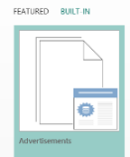
- Open Microsoft Publisher
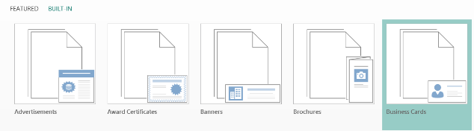
- On the Home page, select Built In
- Select Business Cards. Notice: It’s in alphabetical order.
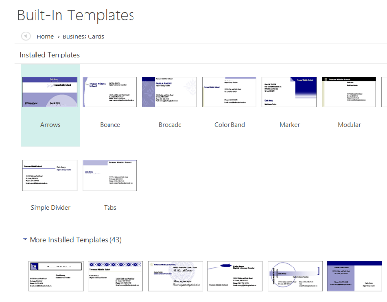
- A new window of Templates pops up. You may choose any template you like.
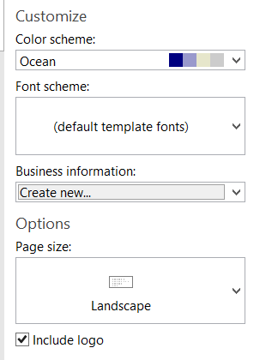
- Once you’ve selected your template, look at the right-hand side of the page for a tab labeled Business Information.
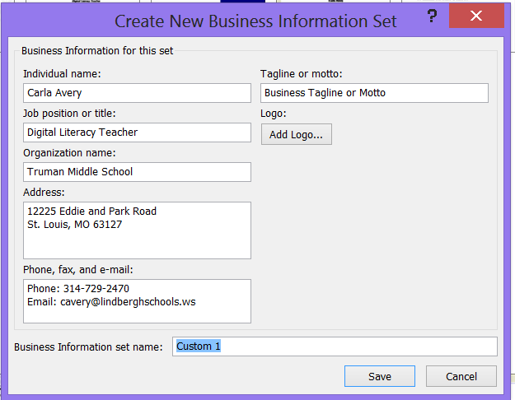
- Click on Create new… A new dialogue box opens. Replace the generic data with your personal or business data. If you are creating a Personal card, you can leave some of the spaces blank. (Job position or title; Organization name)
- For the Address, write your street address for the Primary Line and City, State for Address Line 2. Delete Line 3 & 4. It should look something like this:
12111 Tesson Ferry Rd.
St. Louis, MO 63122
- Use your home or cell phone for the phone number. Use your school gmail for the email address; delete the FAX number—you don’t have one.
- Once you’ve finished typing all of your information, give this profile a name. I used my first and last initial and personal or business depending on the card.
- Next select Create on the right-hand side of the page. Voilà! Your new card is complete.
Of course, if you continue to make changes to the font style, colors, or any other feature that you would like to change.
- To change fonts, simply highlight the text and pick a new style or color.
- To change colors on objects, first ungroup. Remember to click away from the group and then select individual pieces to change colors.
