- What makes you want to see a movie? What do you like the best about previews or movie trailers? What about it makes you want to see the movie? What techniques are used throughout the trailer to hold your attention?
- Book trailer
  - Example of a book trailer
- Where can you make yours?
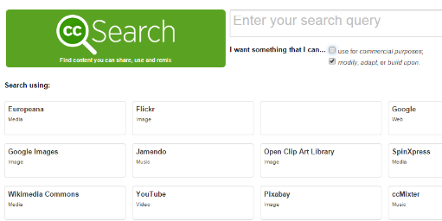
  - Windows Movie Maker
- Where can I get pictures? Remember to not infringe on copyright.
  - Creative Commons Search—Uncheck the box “use for commercial purposes.” Type key search words, select Google or Flicker and enter. Once you find a picture, Visit the Page, right click the image and save it to the Book Trailer folder you created.
  - Flickr: Creative Commons
  - Pics4Learning
When you save, rename the picture. Go up to the URL and select it, right click it and copy. Save this to your Word document to be used for your credits. Remember to adhere to Copyright Guidelines
- How do I start?
Begin with a storyboard. Include the following items:
  - Title
  - Author
  - Important events
  - Don’t give away secrets
  - Use open-ended questions
  - Credits at end—include your name either here or at the beginning
What it looks like put together—Book trailer example.
- Timeframe:
  - You will use a book of your choice or Among the Hidden for your book trailer. Begin working on your storyboard and show it to your teacher. Once your storyboard is approved, you may begin downloading pictures.
  - As you look for pictures, copy the URL and place it on a Word document. Place these URLs on the last slide of your trailer.
  - Finish downloading pictures and begin creating in Windows Movie Maker
  - Work on book trailer.
  - Put the finishing touches on your book trailer. By the end of class, you need to have at least 2 people view your book trailer. Make sure you have everything done.

